Computer Science NEA

Muhammad Zubair

Table of Contents
Section 1: Analysis 2
1.1 Problem Identification 2
Stakeholders 2
Why it is suited for a computational solution 3
1.2 Research 3
Kahoot 4
Blooket 4
Google Forms 5
Quizizz 6
Features of my program considering the research 7
Limitations of my program 7
1.3 Interviews 8
Interview Questions 8
Interview Responses 9
1.4 Requirements 12
Hardware 12
Software 12
Stakeholder Requirements 13
1.5 Success Criteria 13
Section 2: Design 15
2.1 System Architecture 15
Main Modules 15
Flow chart 16
2.2 Database 17
Tables 18
Relationships 21
ERD Diagram: 21
2.3 User Interface Design 22
Start Page 22
Teacher Homepage 23
Student Homepage 23
Login Page 24
Register Page 24
Stakeholder input 25
Improved Design 26
2.4 Algorithms 28
Login Algorithm 28
Registration algorithm 29
Quiz Creation Algorithm 29
Assign Algorithm 30
Quiz Attempt Algorithm 31
Leaderboard update algorithm 31
Key Variables 32
2.5 Validation 33
Text Box 33
Radio Button 34
Button 34
Scale 34
2.6 Testing Methods 34
Testing Checklist 35
Development 36
3.1 Database Development 36
Users Table 36
Quiz Table 37
Question Table 38
Answer Table: 39
Assignment Table 40
Results Table 41
Leaderboard table 42
ERD Diagram 42
Connection to program 43
Database Validation 44
3.2 Login Module 45
Backend code 45
Frontend code 46
Login Testing 48
Evidence of testing 49
3.3 Registration Module 51
Backend Code 51
Frontend Code 52
Test Tables 53

Section 1: Analysis

1.1 Problem Identification
Nowadays many teachers are using paper to test their students. However, this causes some issues as unnecessary paper wastage as a student might me be absent and printed copies go to waste. Additionally, tests on paper also means that means that checking is time consuming and some students would instantly want their scores. These challenges can be solved by using existing digital systems which allow distribution and automatic marking. However, teacher can't use these due to lack of technical skill and high costs of existing solutions.
To address this, I am going to make a Tkinter program which will allow students to take pre-made quizzes or enables teachers to upload their own questions to generate quizzes for their students. I will have to research different programs to evaluate their strengths and weaknesses and learn from them.

Stakeholders
The demographic for this system will be people with computers as the system will be made using Tkinter. The main stakeholders for this system will be teachers and students.
Teachers will be using this program to create quizzes and assign quizzes to their students. This program will be satisfying the teacher’s need as it provides performance reviews for each student individually, support for different question types and automatic marking. Features like these will save the teacher’s valuable time and bring awareness to their students’ progress.
Students will access quizzes assigned by their teacher by using a key or attempting quizzes made publicly available. Feature like simple interface and engaging elements will ensure that the quizzes are motivating and that the program is easy to use.
Moreover, IT staff, parents and headteachers may be considered secondary stakeholders. IT staff are secondary stakeholder as they will be responsible for making the program is running smoothly for the teachers and the students. Parents are a part of this category as they care for their child’s wellbeing and would be interested in a software that would motivate them to study more. Headteachers are secondary stakeholder as well, since they are responsible for funding and reporting student progress to the government. A software solution with tracking and report will be an interest to them.

Why it is suited for a computational solution
For this problem a computational solution is much more suitable as the problem can be broken down and solves using computational techniques. Quizzes and assessments done on paper cause unnecessary paper wastage and time as teachers must mark it manually, whereas if these quizzes were computer based then it can automatically mark answers, and create detailed performance reports for each student which will save time and effort.
By using decomposition, the programs can be split into smaller tasks which are manageable such as creating quizzes, marking quizzes, generating a performance reports, and displaying results. This structure will make sure that the development of this project will be smooth and easy to implement.
Abstraction will also be vital to the development of this program as it does not need to replicate the details of how teachers create, and mark quizzes as done on paper. It will focus on the essential elements such as displaying questions, taking input, marking the answers and providing feedback. This will make sure that program will be user friendly and easy to use.
Furthermore, the program will benefit from automation, as the program will be able to automatically perform task such as marking quizzes, storing data and generating reports. This will reduce the workload for teachers, saving their time and reducing human error. By using pattern recognition, the program can mark long written answers by searching for keywords required in the answer. This will allow students to write answers in multiple ways and ensuring they are marked correctly by using automation.
Overall, these examples show that computational methods are reliable and way more effective than a paper-based system. It also showcases that this problem can be solved by computational methods as it uses databases, algorithms and pattern recognition.

1.2 Research
I will research a range of different programs as each program has its unique strength and weaknesses. I will also understand what features worked well in their program and what didn’t. This will help me in deciding what features I should use in my program so that it is user friendly and serves its purpose.

Kahoot
Kahoot is an online interactive web and app-based system that was launched in 2013 and lets teachers create quizzes that their students can participate in real time. It is popular as it allows learning by having competitive and interactive gameplay. Teachers act as the host in Kahoot and share a pin code which students can enter to access the quiz.
Strengths:
- Cross-platform: Can be used on mobile, tablet and laptop
- Engaging interface: Leaderboard and colourful UI creates a fun and competitive environment
- Easy access: Only host needs an account, participant don't need an account to access quiz
- Multiple question types: Support multiple-choice questions, polls, true/false and puzzles
- Collaborative system: Hosts can reuse quizzes or use existing ones
Weaknesses:
- No offline access: Needs internet which limits usability in some schools
- Different versions: The free version has less question types and daily limit on quizzes whereas the paid version provides more features
- Loud Countdown: Timers can cause stress for some students
- Limited answer types: Doesn’t accept long answers which means teachers cannot see the student’s understanding of the topic
Relevance to my project:
By evaluating Kahoot’s strengths and weaknesses, I have identified multiple features that I can include in the project which will meet the user’s needs. From Kahoot's strengths, I can integrate a colourful interface and support for different question types which will make the quizzes more interactive and engaging. From its weaknesses, I can improve the system by providing offline access, ensuring access to school without internet, and allowing longer written answers which will guarantee a better and flexible user experience.

Blooket
Blooket is a quiz style game that was launched in 2018 and allows teacher to create or select premade quiz. These quizzes can be played in a variety of game modes. Similarly to Kahoot, students enter a unique code to access the quiz. Blooket has in game currency and powerups which makes it feel like an actual game.
Strengths:
- Multiple game modes: It has game modes such as battle royale and café which gives option to the students and keeps them engaged
- In game currency: Allows players to buy powerups and motivates players to keep playing to get more currency
- Replay ability: Same quizzes can be played with different game modes which keeps the game fresh
- Customisable quizzes: Teachers can create their own quizzes or choose quizzes from a public library
Weaknesses:
- No offline mode: Requires internet which means students without internet can’t use it
- Distraction: The game elements can distract some students from learning
- Learning curve for hosts: Some game modes are confusing for the first time for hosts and students
- Different versions: Paid version gives more desired feature such as advanced game modes, but some students might not be able to afford it

Relevance to my project:
By evaluating Blooket’s strength and weaknesses, I have identified several features which I can incorporate into my project to have engagement just like Blooket. From its strengths, I can integrate multiple quiz modes which will make sure that the students are engaged and maintain interest. However, I must make sure that I don’t overcomplicate the game modes, so it isn’t difficult enough for first time users to understand. From its weaknesses, I can make sure to have just one version of the program and allowing offline functionality which enables access for all users regardless of internet availability.

Google Forms
Google Forms is a free web-based tool that is mostly used for quizzes, questionnaires or surveys. Forms can be customised with different colours and themes, and the answers can be automatically stored in google sheets which makes storing and analysing the gathered data simple. It is mostly used in education as teachers can easily make assessments, share them with students and collect responses which can automatically be stored and organised into Google’s database.
Strengths:
- Free: Anybody with a google account can use it
- Automating marking: The MCQ questions can be instantly marked which saves teacher’s time
- Data management: It automatically stores the responses into Google Sheets where the data can be analysed
- Ease of use: The simple interface means that teachers can create quizzes easily
Weaknesses:
- Requires internet: Cannot be used when offline
- Lack of engagement: It has no interactive or game like elements which makes the quizzes feel plain compared to Blooket or Kahoot
- Account dependency: Students need google account to submit responses which can be inconvenient for students that are underage
- Limited customisation: Can only use basic themes and different formats
Relevance to my project:
By evaluating Google Forms’ strengths and weaknesses, I have identified features that I can include in my project to increase user satisfaction. From its strength, I can take inspiration from its simplicity and automatic marking, which makes it easy to use for teachers. I can improve on its weakness by making the interface of my project more visually appealing and supporting a variety of different question types. These improvements will make sure that the system is appealing and beneficial to the user.

Quizizz
It is an online quiz platform which allows teachers to create quizzes which can be shared with students. Quizizz allows the quizzes to be self-paced which allows them to work at their own pace, unlike Kahoot which pressures students with a timer. It uses memes, leaderboards and avatars to make the experience engaging for students and allows teachers to view detailed reports of their performances for each student.
Strengths:
- Self-paced mode: Allows students to complete quizzes in their own time which reduces stress and offers flexibility
- Gamified elements: Makes the quizzes fun and engaging by using avatars and memes
- Detailed reports: Teachers can view detailed reports for each student and track their performance
- Automatic marking: Multiple choice questions are instantly marked, which saves time for the teacher
Weaknesses:
- Distractive elements: Some teachers have given feedback that the game elements distract students from the real task
- Limited question types: It only has multiple choice questions and fill in the blank questions, and doesn’t allow long written answers
- Required internet access: Doesn’t work without internet access
Relevance to my project:
By evaluating Quizizz’s strengths and weaknesses, I have identified multiple features that I integrate and improve on in my program. From its strengths, being able to have flexibility on when to complete the quizzes in your own time as it makes the experience comfortable and less pressure inducing. Additionally, having gamification such as avatars and memes can make the program more engaging and enjoyable for students. From its weaknesses, I will make sure that my program can be used when offline so that schools without internet access can still use it. I will also make sure that it supports long written answers which will allow teachers to assess student’s knowledge more effectively.

Features of my program considering the research
By evaluating multiple existing quiz programs, I have recognised key features that I can integrate into my program which will make it efficient, satisfactory and user friendly for the user. By evaluating the strengths of programs such as Kahoot and Quizizz, I have learned the importance of adding game like features and supporting multiple question types which will keep the user engaged. From their weaknesses, I have also learned to keep the program simple, so that it is easy to navigate for first time users. From Google Forms, I have identified having a simple interface which will make it easy to use and having automatic marking which will be easier for teachers to use and save their valuable time. Furthermore, I have also identified that all programs share a weakness, such as having no offline mode and no support for long written answers. Addressing these issues in my project will make sure that my program will be efficient, reliable and engaging for teachers and students.

Limitations of my program
The main limitation of my solution will be that it won’t be cross platform like all my researched programs. Since Tkinter is being used to build the program suitable for desktop operating systems such as Windows or MacOS. While it is possible to run Tkinter on android devices but doing this would bring problems like performance issues and difficulties in designing a user interface for touchscreens. Solving these issues will require additional time which will take away my focus from the developing of the main features.
Another limitation is that my user interface won’t be visually pleasing or engaging as Tkinter’s widgets are simplistic. As a result, the interface will look bland compared to programs such as Kahoot or Quizziz. Moreover, Tkinter’s design option are limited which means animated feedback or interactive features won’t be available. However, I can use this to my advantage as this will prevent clutters which means the interface is simple and doesn’t allow user to get distracted by the visual effects. This means that my program will be faster on school computers as it won’t demand high graphical performance.
Finally, large scalability may be a limitation as the program won’t be suitable for large classrooms as it can’t handle hundreds of people simultaneously accessing the dataset. This is because the data is stored in the local file based database rather than a centralised database.

1.3 Interviews
I will interview a range of stakeholders, students and teachers, and ask them questions which will help me understand their wants and needs. These interviews will give me feedback from the people who use quizzes software regularly. From their feedback, I will make sure that system is integrated to meet the stakeholders’ requirements.

Interview Questions
Questions for Dr. Robert (a teacher):
- How do you currently give assessment or quizzes to your students?
- Is using a paper-based quiz challenging?
- What quiz program have you disliked? If yes, then why?
- What features would you like to see added in your most used quiz programs?
- Is automatic marking and instant feedback important to you?
- Do you think quiz apps generating detailed performance review for students will be useful?
- Is it important for the program to work offline?
Question 1 and 2 is learning about what type of method they are using to assess their students. This will make sure that using a digital solution is the right approach.
Question 3 and 4 is getting feedback about the programs that the teacher has used. By learning what they disliked and liked, I can identify the weaknesses of the programs and make sure mine doesn’t repeat them.
Question 4, 5 and 6 are asking about specific feature that were identified as strengths or weaknesses during my research to see if teachers truly value those features and are worth adding in my program.
Questions for John and Aarron (are students):
- Do you prefer taking quizzes on paper or digitally?
- What do you like about paper quizzes?
- Would you like having a timer or being able to complete quizzes on your own pace?
- Do you think it is useful to give instant feedback after you have answered?
- Would you like to see a performance report of yourself after you have completed a quiz?
- What features in quiz programs make it engaging for you?
- If you could improve one thing about online quizzes, what would it be?
Question 1 and 2 is identifying their preference over digital and paper. It is also identifying what students like about the problem we are trying to solve. This will confirm if a digital solution is effective.
Question 3 is asking about pacing and will help us identify what students prefer. This will identify if students prefer to work under pressure or would like flexibility. This will help me the decide if the pacing should be customisable or optional.
Question 4 and 5 are identifying if students like to see feedback of their performance. This will confirm if feedback and performance reports are truly useful for students and are worth adding.
Question 6 and 7 are identifying what features make it engaging for students and collect new ideas about features to add. Adding these features will show that the students’ opinions are valued.

Interview Responses
Dr Robert:
- How do you currently give assessment or quizzes to your students?
“I mostly give paper-based quizzes, mostly when I give shorter assessments, because it’s quick to distribute in class. For digital, I use Google Forms for multiple choice style questions when I want instant marking.”
- Is using a paper-based quiz challenging?
“Yes, marking them is very time consuming, and all the paper in one place is difficult. It also takes a lot of my personal time to mark and give feedback.”
- What quiz program have you disliked? If yes, then why?
“Students prefer Kahoot as they find it engaging, but I dislike that students start getting distracted over the leaderboard and start making a fuss. It’s fun and engaging, but not always the best for proper assessment.”
- What features would you like to see added in your most used quiz programs?
“I’d like a system where my students can write long written answers and can still get automatically marked. Most quiz programs are limited to multiple choice questions or one word answer questions, which doesn’t test deeper understanding of the students.”
- Is automatic marking and instant feedback important to you?
“Yes, absolutely. It saves me a lot of time and students prefer seeing where they went wrong as they can improve from their errors.”
- Do you think quiz apps generating detailed performance review for students will be useful?
“Yes, have a detailed performance review is extremely useful as I can evaluate it and adjust my curriculum according to it. It will also be useful for me as I can just send my students this performance review as their progress checks.”
- Would you prefer if the quiz program works offline?
“Yes, that would be a gamechanger. The internet at school is slow, so having the quizzes work offline means that my students can access the quizzes without any issues.”
Analysis:
Dr. Robert’s response shows that paper-based quizzes are still common because they provide ease of use. However, he did mention that it creates more workload for him when marking. This means he would benefit from automatic marking as it would save his time and reduce his workload. Dr.Stout also values instant feedback as it allows his students to improve from their errors. Furthermore, he mentioned that performance reviews will further reduce workload for teachers as the performance reviews can act as ready-made feedback for students. He also emphasises that being able to write long answers as it provides a better measure of students understanding of a certain topic. Finally, he also pointed out a major weakness in existing programs such as lack of offline functionally which limits accessibility. From this feedback, I can see that my program should focus on efficiency and flexibility which will meet the teacher’s needs.
John:
- Do you prefer taking quizzes on paper or digitally?
“Digital quizzes are better because they are faster to complete because typing is faster than writing. The answers are instantly marked which means I know what to revise.”
- What do you like about paper quizzes?
“Doing quizzes on paper means that I can brainstorm on the paper and I can complete questions in an order I want.”
- Would you like having a timer or being able to complete quizzes on your own pace?
“I wouldn’t like timers as I would like to complete quizzes on my own pace. Timers also make me feel pressured and prone to more mistakes.”
- Do you think it is useful to give instant feedback after you have answered?
“Yes, this will teach my about mistakes, so I don’t do them again.”
- Would you like to see a performance report of yourself after you have completed a quiz?
“It would be helpful as I could see all the topics I need to revise.”
- What features in quiz programs make it engaging for you?
“I like seeing leaderboards as it adds competition which motivates me to do better.”
- If you could improve one thing about online quizzes, what would it be?
“Maybe more options for question types because MCQs get boring and it is nice to some variation. If there is a long answer option, then I can explain my answer better.”
Aaron:
- Do you prefer taking quizzes on paper or digitally?
“I prefer doing quizzes on paper because the digital quizzes are too distracting and, I focus better when writing on paper.”
- What do you like about paper quizzes?
“I can write anywhere I want, do rough working and draw diagrams which will help my write answers better.”
- Would you like having a timer or being able to complete quizzes on your own pace?
“I like the timer as they help me focus and stop me from overthinking or overcomplicating.”
- Do you think it is useful to give instant feedback after you have answered?
“I don’t like instant feedback as if I start getting wrong answers in the beginning, I get discouraged and makes me want to quit.”
- Would you like to see a performance report of yourself after you have completed a quiz?
“I would like to see more competition elements such as leaderboards.”
- What features in quiz programs make it engaging for you?
“It should be more based on understanding the topic instead of it being a race.”
- If you could improve one thing about online quizzes, what would it be?
“I would like to be able to use these programs without internet so I can use them when travelling.”
Analysis:
Both students have shown contrasting preference between digital and paper-based systems, which shows that flexibility is a crucial pillar in the program design. John prefers digital as they are faster, provide instant marking and keep it engaging by using game like elements. This proves that features like automatic feedback and gamification will be quite beneficial as they will keep the quizzes engaging and effective. However, Aaron preferers paper-based quizzes as he can freely draw diagrams and rough work. He also mentioned that he wouldn’t want instant feedback for each answer, as it discourages him from continuing the quiz if he performs poorly in the start. Overall, these responses show us that students have different needs as some prefer to complete at their own pace, or some prefer to work under pressure. This means that the program should add optional timers, offline functionality and allow long written answers which will satisfy a wide range of learners.

1.4 Requirements

Hardware
These are the minimum requirements for the hardware which will ensure a smooth experience for users.
- Processor: Dual core
- RAM: 4 GB
- Storage: 200 MB
- Display: 1280 x 720
These requirements show that expensive or high end hardware is needed as Tkinter is a lightwork framework. This also ensures that almost any personal computer or school laptop can run the program smoothly.

Software
Software is also important as hardware as they both work in conjunction with each other.
- Window, macOS or Linux operating system: These operating systems are needed to run Python and Tkinter
- Python Interpreter: The code will be written in python so an interpreter will be needed
- Python Libraries: These libraires contain CSV and Tkinter which will allow various function of the program
These requirements will make sure that the program is easy to use and has no external dependencies.

Stakeholder Requirements
Design
Requirements | Explanation
Simple interface | This will allow teachers to easily create quizzes or assign quizzes without any training beforehand
Clear fonts | Students and teacher will both be able to read it comfortably
Quiz feedback should be able to load quickly | This will mean that students can access their requirements faster and can learn from their mistakes.

Functionality
Requirements | Explanation
Allow different question types | This will allow teacher to test their student for deeper understanding of the topic
Automatic marking | Reduce the teacher’s workload and allow students to instantly see their answers
Instant Feedback | This will generate performance reviews for student and tell them how much they have improved
Offline functionality | This means that school with weak internet will be able to run the program smoothly
Game like elements | This will add features such as avatars and leaderboards which will offer competition and boost engagement
Data stored in CSV | Allow teacher to import data and give feedback to their students

1.5 Success Criteria
No. | Success Criteria | Explanation
1 | Create quizzes with different question types | Gives teachers flexibility and allows them to better test their students understanding
2 | Allow option to enter codes or select from a public library to access quizzes | These codes will allow students to access the quizzes assigned by the teacher. The public library will make sure that the students have freedom to practice what they want
3 | Program must make users sign in or sign up before accessing the home page | This will make sure that users’ data is saved to the local files and cannot use the services without an account
4 | The program must run smoothly on the minimum hardware requirements | This will make sure that school laptops will be able to run the program efficiently
5 | Interface must be simple and easy to navigate | This will make sure that the program is easy to use for students and teachers.
6 | Program recognition should be used to mark long answer questions | This will save teachers time because they don’t have to check long lines of answers looking for the keywords
7 | Data and result should be stored in CSV files | This will also allow teachers to track their students’ progress
8 | Program must work without internet | This will make the program more accessible as it can work without internet
9 | Allow teachers to include optional timers | This will allow teachers to give their students flexibility
10 | Program should generate performance reviews within 5 seconds | This will allow students to learn what topics they are weak at and see if they are improving
11 | Program should have a global leaderboard | This will create competition and motivate students to keep attempting quizzes
12 | Students can access their past results | This will allow students to see how much they have improved
13 | The program should be rid of 99% of the bugs | This will ensure that students and teachers are able to run the program smoothly
14 | Listen and respond to player feedback | Makes sures that the program fits the needs of the users
15 | The program gives responses for wrong input | Will inform users if they have entered wrong input and will prevent crashes
16 | Program should respond to users input swiftly | Users will be able to control what they want to do without any delay
17 | Quiz answer should be encrypted | Users won’t be able to find the answers by opening the file as they will be gibberish
18 | Allow three password attempts | Will prevent brute force and make sure that user accounts are safe

Section 2: Design

2.1 System Architecture
My program will start by requiring the user to log in. If the user doesn’t have an account, then they can register. When the users log in, they system checks what if they have a student's account or teacher account and then sends them to their respective homepage.
The teacher’s homepage comprises of options allowing teachers to create quizzes, edit quizzes, test quizzes, assign quizzes, view performance report, and access leaderboard. The “Create Quiz” button takes to the quiz workshop where it asks what type of questions and number of questions the teacher wants. The “Edit Quiz” button takes the teacher to the quiz workshop and allows them to edit quizzes. Quizzes that are created or edited are saved into the local database and the answers are encrypted for security. The “Test Quiz” button allow the teacher to view quizzes from the public library quizzes or their own collection as a student sees them. The “Assign Quiz” button allows them to select a quiz which then generates a code, this code can be given to the students so they can access the quiz. The “Reports” button allows the teacher to see the performance reports of students who have attempted the quiz. The “Leaderboard” button will allow teachers to view the leaderboard which can be used to compare the students.
The student’s homepage also has options to practice quizzes, enter a code, view the leaderboard, and check their performance report. The “Practice Quiz” button allows students to access the public library and select any quiz to practice. The “Enter Code” button summons a text field allows a code to be inputted which allows to complete teacher assigned quizzes. The “View Leaderboard” button will allow students to access the leaderboard and see their ranking. The “Reports” button will allow students to see their results of their past quizzes and allow them to track their progress.
All the quizzes, results, accounts and leaderboards will be stored in a local database. Teachers will mainly write to database by crating or editing quizzes whereas students will primarily read data as they attempt quizzes and view reports. The login system makes sure that teachers can only manage quizzes. My system’s architecture is modular which allow me to add new feature without disrupting the main features.

Main Modules
I will use decomposition to split the architecture into different modules which will allow me to complete the system faster. The main modules will consist of:
- Authentication module: This will allow existing users to login and allow new users to register. This will also be used to differentiate between teacher and student account which will then redirect to the appropriate homepage.
- Registration modules: Asks the user for account type, age, full name and password. This data is stored in the local database as well as the encrypted password.
- Teacher homepage module: Allow teachers to do multiple actions such as quiz creation, editing, testing, assigning. It also allows viewing of the performance reports and leaderboard.
- Creation module: Allow teachers to create questions by inputting the type of questions and number of questions. The system then prompts the teachers to input the question and their answers. The questions are then stored in the local database alongside the encrypted answers and in the teacher’s private library.
- Editing module: Teachers can select a quiz from the public or private library. The editing module allows teachers to delete, edit, add questions or edit answers. The quiz is then updated in the local database and is also stored in the private library.
- Assignment module: A quiz can be selected from the public or private library which then generates a unique code. The teacher also has an option to invalidate the code.
- Testing module: Allow teachers to preview the quizzes as students and makes sure that the quiz is working as intended.
- Student homepage module: Gives students the option to practice quizzes, enter a code, check their reports or view the leaderboard
- Practice module: Allow students to practice quizzes from the public library. This allows them to practice independently. The student has an option to save the results in the local database.
- Code module: Allows students to enter a unique code when prompted for which allows them to access the teacher assigned quiz. The results of these are saved in the local database which teachers can access
- Performance module: Allow teachers to see the result of students who have completed the assigned quizzes. Gives students access to their all their results and allow them to assess their progress.
- Leaderboard module: Teacher and students can both access the leaderboard, and students can see them ranking which adds competition.
- Database module: It is responsible for storing all the data such as quizzes, accounts, results and the leaderboard. Allows data retrieval for both teacher and student functions.
- Error Handling module: Responsible for handling all errors such as invalid code, missing quiz or any database error

Flow chart
Flow charts are another way to represent algorithms. They are easy to understand and show the flow of data. The flowchart also showcases how each module is linked to each other and used to highlight the most important processes.
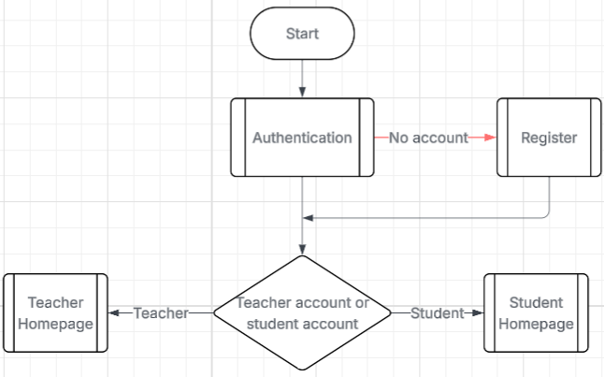
Below is a flowchart representing the whole system and viewed through abstraction. This clearly shows what the programs core processes are and allows better understanding of the program to stakeholders or users.

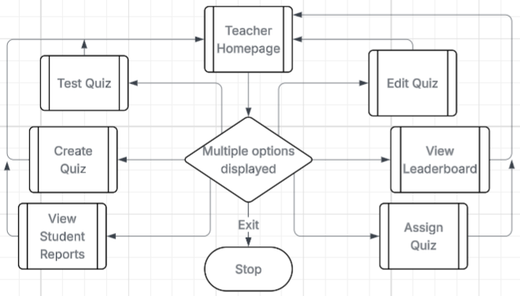
This is the teacher’s homepage which is being shown in flowchart form. This display what the main features of the homepage are and shows how all of them are linked. This will be useful when evaluation as I will be able to know if I have fulfilled all the functions.
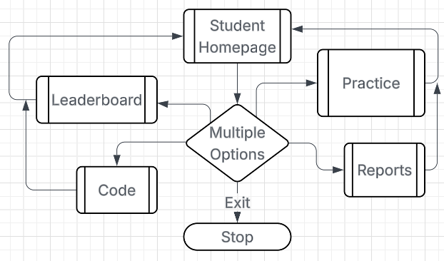
The student homepage is being visualised by the flowchart and provide a better understanding of how it will work. It shows how simple the student homepage will be under the interface.

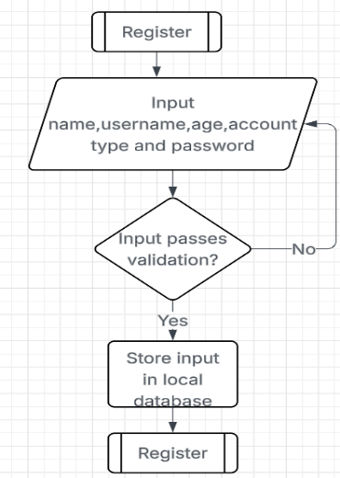
The registration module is being show by a flowchart and it is an important function it lets first time user to sign up and access the program. The validation of input is really important as it prevents any SQL injection or errors in the database.

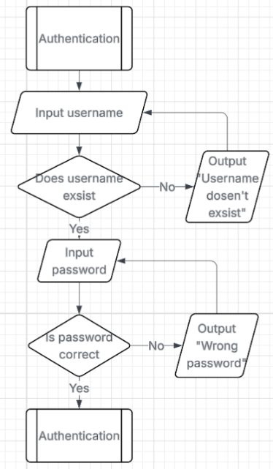
The authentication function is just the login system which will allow teacher and students to access their program. The flowchart highlights that checks are done by the function to ensure the actual user is logging in and has validation to prevent SQL injection.

2.2 Database
The database required for the program will be implemented using SQLite as it is lightweight and can be easily integrated with Tkinter. It will store all the quizzes data such as user details, questions, answers, leaderboard, assignments and results. This will allow teacher and students to use the same program and still access their data.

Tables
Users Table:
It will be used to store data of users. Every user will have a unique “user_id” and a “role” which will decide what the user can access.
- user_id (Primary Key) – Unique identifier for each user (integer value)
- name- The users full name (string value)
- username- Name of the user (string value)
- age- Age of the user (integer value)
- password- Hash password of the user (string value)
- role- Will either be teacher or student (string value)
Below is the code of this database:
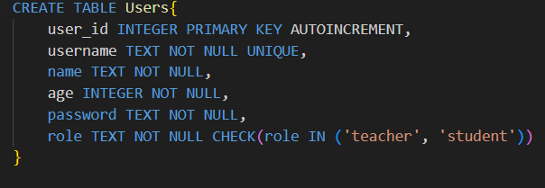
Quiz Table:
It will be used to store quizzes created by teachers or available in the public library.
- quiz_id (Primary Key)- unique identifier for each quiz (integer value)
- created_by- Will either store the teacher’s name who created it or a value called “ public” which means everyone can access it (string value)
- title- Store the title of the quiz (string value)
Code of the database:
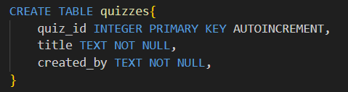
Question table:
This database will store questions for a quiz. The question table and quiz table will be linked using “quiz_id”.
- question_id (Primary Key)- unique identifier for each question (integer value)
- question_type- will store either MCQ, TrueFalse, ShortAnswer, LongAnswer which will let the system know what type of question it is (string value)
- question_text- the question which will be displayed to the user (string value)
- quiz_id (Foreign key)- Link the table with quiz table so the questions can be accessed
The code:
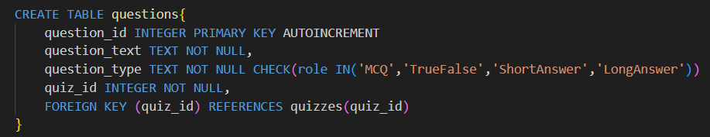
Answer table:
Store the answers, a question can have multiple answers. An answer can also be wrong which is useful for MCQs
- answer_id (Priamry key)- unique identifier for each answer (integer value)
- answer_text- store the text of the answer which will be displayed to the user (string value)
- question_id (Foreign Key)- will link the answers to the question
- correct- will store if the answer is correct, this is useful for MCSQs as it displays only one correct answer (Boolean)
Code:
Assignment table:
This table will store and keep track of assignments given by teachers.
- assignment_id (Primary Key)- unique identifier for each assignment (Integer Value)
- assigned_by- store the name of the teacher which has assigned the quiz (String Value)
- valid- This will tell if the assignment is valid or not (Boolean Value)
- code- This will be used by the students to access the assignment (Integer Value)
- quiz_id (Foreign Key)- Will allow to access the assigned quiz (Integer Value)
Code:
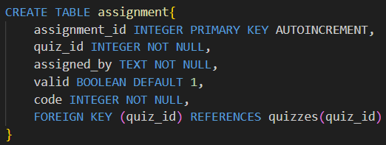
Result Table:
It will store the results of quizzes attempted by students. Data from this table will be combined to give the students report.
- result_id (Primary Key)- unique identifier for each result (Integer Value)
- completed_by- Store the name of the student (String Value)
- quiz_id (Foreign Key)- Store the result of the quiz (Integer Value)
- result- Store the result of the quiz (Integer Value)
- date_taken- Will record when the quiz was completed and result was stored
Code:
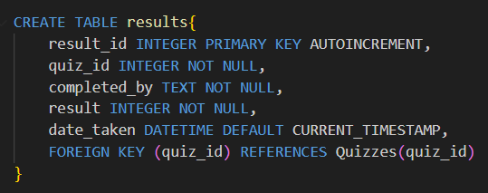

Leaderboard table:
Will be used to track the ranking of students and will be used to display the students by the tank of their score.
- Leaderboard_id (Primary Key)- unique identifier for each record in the leaderboard table (Integer Value)
- username- will be used to track the person’s record (String Value)
- score- will be used to determine the order of the leaderboard (Integer value)
Code:
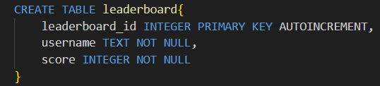

Relationships
This will highlight how tables are linked to each other.
User to Quiz (One to many)
A teacher can create and edit multiple quizzes whereas the quiz can only be created by one teacher.
Quiz to Question (One to many)
A quiz can have multiple questions. However, a question can only belong to one quiz.
Question to Answer (One to many)
A question can have multiple answer such as MCQS and long answers as they need
Quiz to results (One to many)
A quiz can have multiple entries in a results table, but a result can only be associated with one quiz.
User to Leaderboard (One to One)
The user table can only have one entry in the leaderboards table as the rank is updated after an entry in the results table. A student can have only have one leaderboard_id and a leaderboard_id can only be related to one student.
User to Quiz (Many to Many) via Results
A quiz table can be completed by many students, and a student can complete multiple quizzes. This is connected via the results table which acts as bridge between the user and quiz table

ERD Diagram:
This diagram shows all the tables and the relationships between them. The diagram provides visualisation to easily understand the relationship between tables.

2.3 User Interface Design
A user interface is very important as it allow the user to communicate with software and tell it what to do. This is why I must design a simple user interface, so it is easy to use for students and teachers. This is because of the research I did into existing solution which showed that some program was difficult to navigate for first time users.

Start Page
This is the first thing users will see when they open the program. It has vibrant colours and a button which will direct the users to the login page. The size of the interface is 1200x800 which all the interfaces will also follow.
This links back to my success criteria about being simple and clear as the interface tells what the program name is and has one button.

Teacher Homepage
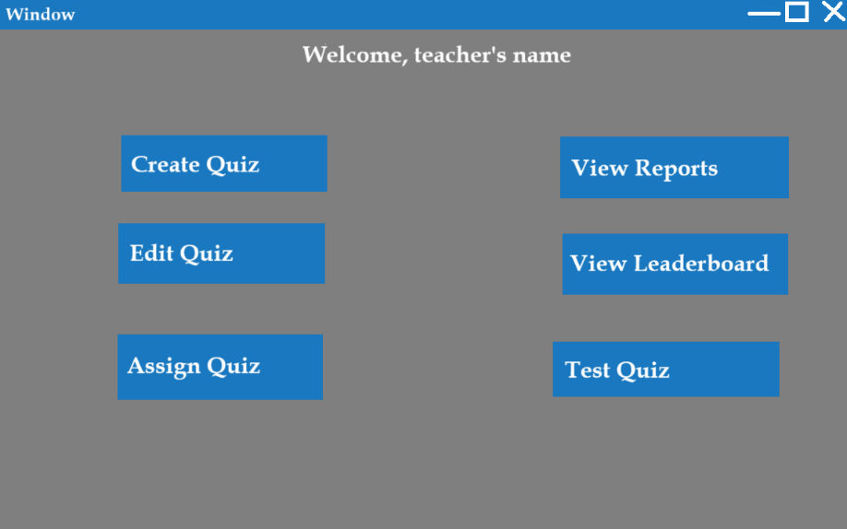
This is the teacher’s homepage, this will allow teacher access to the main functions. The design is simple and has two columns of buttons for simplicity. The left column gives teachers quiz management tools and the right side gives monitoring tools.
This links back to my success criteria which specified that the interface should be simple and easy to navigate. This also links to another success criteria as the interface has no graphical demanding elements which means the program can run at the minimum requirements.

Student Homepage
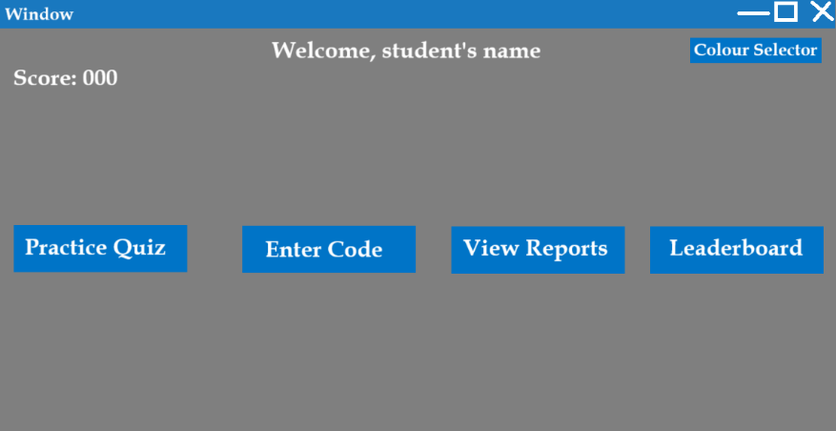
This is the student’s homepage which will allow students to navigate through the program. The homepage has all the necessary functions and even greets the student. There are four buttons in a single row to show simplicity and even has a colour selector which changes the colour of the home page which allow the interface to feel fresh for students. There is even a score counter, which motives students to complete more quizzes. The space allows for more features without redesigning the whole page.
This links back to my success criteria about a simple interface as everything is clear and easy to navigate. This also links back to the success criteria which allow the students to access past reports and the leaderboard.

Login Page
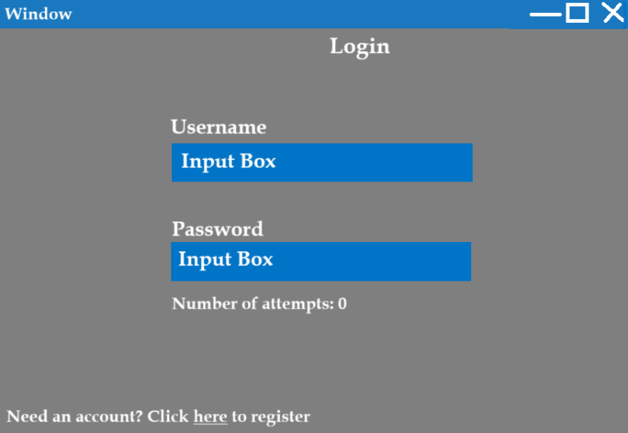
This is the login page of the program which will allows both teachers and students to securely access their respective homepage and access their features. Users can login by entering their username and password in the input boxes. A login attempt counter is also displayed to warn users of the program being locked. There is also a redirect button which takes first time users to the register page.
This links back to my success criteria as the interface is simple and consistent across all pages. The login attempt counter also links back to another success criteria as it prevents unauthorized access.

Register Page
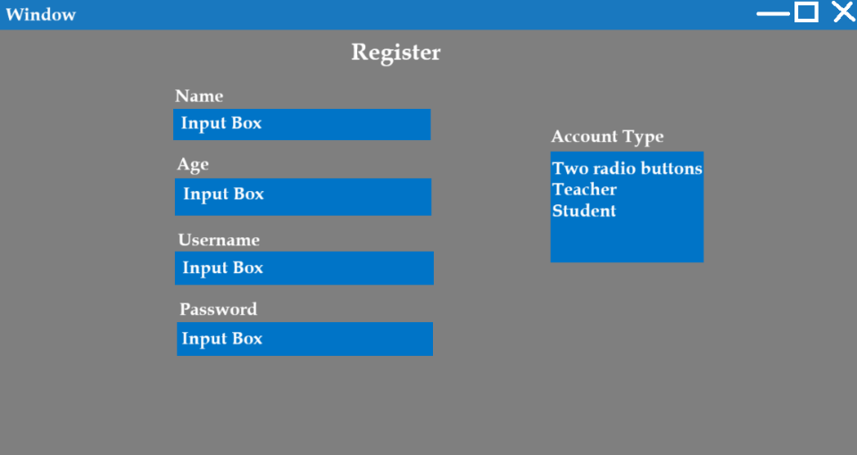
This page will allow first time users to register and access the quizzes. The page asks for the user information which can be entered through the input boxes and be saved in the users table of the local database. It also features radio button which allows users to only select from two options (student and teacher) which will prevent input error
The theme and layout are still consistent with the rest of the pages, which links back to the success criteria of the interface being simple and easy to use. Following this design means that first time users can easily signup without any confusion.

Stakeholder input
The email I will be sending to the stakeholders:
Hello (name),
I am contacting you as I need your feedback on the user interface designs, I have made for the program. Please write what you liked about the interface and what improvements can be made to make it easier to use.
Thanks,
Muhammad Zubair
I will be sending this email to my stakeholder with a folder attached containing the designs and asking for their opinion. This will let me know if my current interface meets the requirements and make any improvements that are needed.
Response from Dr. Robert:
Hi Muhammad,
I appreciate it that you are keeping me up to date on the development of the program. These user interface designs look good, the interface is not cluttered, and it clearly tells what each button does. However, I do think that you should add the theme selector on the teacher homepage. I would loving having the theme selector as it would make the teacher homepage feel fresh and unique.
Thanks,
Dr. Roberts
Response from John:
Hello Muhammad,
The design looks good, but the colours are ugly for me, and I love that you added a colour selector which means I can change the colour to my liking. Another thing is that the buttons need to have equal distance as it very noticeable. Other than that, it looks good, and I am excited to try the finished program.
Response from Aaron:
Hello Muhammad,
Your interface has good things such as clear options, a personalized message and a colour selector. There are however some negatives about the design such as the empty spaces, and no text resizing for people with bad eyesight. Other than that, it looks pretty good.
Summary:
I have interviewed all three stakeholders and find out that they really love the theme selector as it allows them for personal personalization. I will also add the theme selector to the teacher homepage due to Dr. Robert's feedback. I also must make sure that the symmetry of the design is flawless and there are no big gaps in the design. Aaron suggested an accessibility feature which allows text resizing and makes it more user friendly. Overall, the feedback gave me an insight on what changes I need to make, so the stakeholders are satisfied.

Improved Design
Based on the feedback form the stakeholders, I will be making improvements to the user interface. These improvements will make sure that interface is more user friendly and has a simple design.
This is the updated version of the login page. I added a colour selector and text resize button which allows the user to customise the page to their choice.
Tis the updated version of the teacher’s homepage. I have added features that Mr. Roberts recommended and added the text resize button to make the program more accessible.
This is the updated version of the student’s homepage. I have changed the layouts of the buttons, so it looks more appealing and simpler. The resize text buttons will allow students to change text size according to their liking.

2.4 Algorithms
This section will highlight the details of the main algorithms which are required to run the system. Doing this will give visualization and give ideas for improvements.

Login Algorithm
This function will allow users to login. The function will take in username and password as parameter, and the function will validate against the user table that the details are correct. The function will return a code to signify what has happened. The function also ensures that users with more than three attempts will be locked out.
Pseudocode:
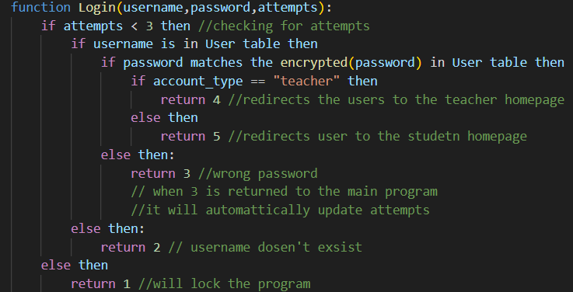
Key variables:
- username (string)- stores the username inputted by the user and is used as the identifier of an account
- password (string)- stores the password inputted by the user and is used to authenticate the owner of the account
- attempts (integer)- tracks the user’s number of failed attempts

Registration algorithm
This algorithm allows first time users to create an account. It will take name, age, username, password and account type as parameters which will then be saved into the user’s table. The username is also checked to avoid relating usernames. The password is encrypted by the hash function before saving to ensure account security.
Pseudocode: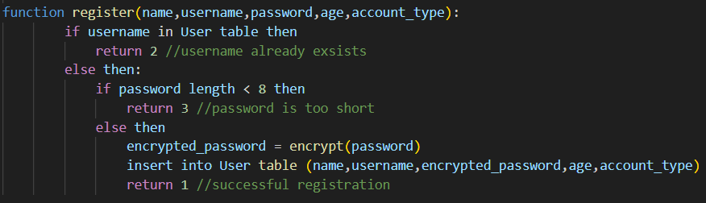
Key variables:
- username (string)- used as identifier for login
- name (string) – stores the full name of the user
- password (string)- chosen by user to authenticate when logging in
- age (integer)- stores the age of the user (for future statistics or verification)
- encrypted_password (string)- stores the hash of the password which is then stored in the table for better security
- account_type (string)- can be either “teacher” or “student” and is used to identify which homepage to send the user to

Quiz Creation Algorithm
This function will be used to create brand new quizzes by teachers. It will ask for user input for the questions and answers. The data will all be stored into the quiz table, user table and answer table.
Pseudocode:
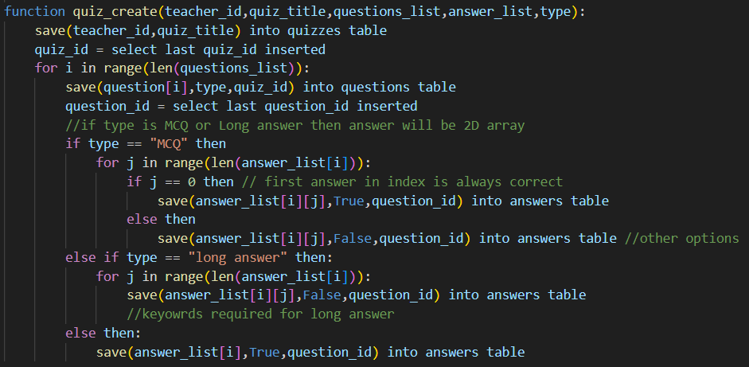
Key variables:
- teacher_id (integer value)- Unique identifier for each teacher
- quiz_title (string value)- Stores the name of the quiz
- type (string value)- Stores the type of question such as “MCQ”, “Short Answer”, “True/False” or “Long answer”
- questions_list (list)- Stores all the questions in an array
- answer_list (list)- Stores all the answer in an array or 2D if the question type is “long answer” or “MCQ”

Assign Algorithm
This function will be responsible for generating a code that the students will use to complete their assignments. The details of the quiz are stored in the assignment table which links the code and quiz together.
Pseudocode:
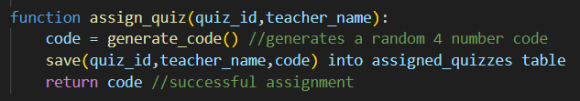
Key variables:
- quiz_id (integer value)- a unique identifier for each quiz
- code (integer value)- random 4 digit code that is going to be used by students to complete assignments
- teacher_name (string value)- stores the name of the teacher which will be used to recognise all the assignments by a teacher

Quiz Attempt Algorithm
This function will be used by students to attempt quizzes assigned by their teacher. The students will input a code which will allow them to access the quiz. The results of this quiz will be saved in the results table. This will be a very big function as it will deal will all question types and displaying the questions and answers.
Pseudocode:
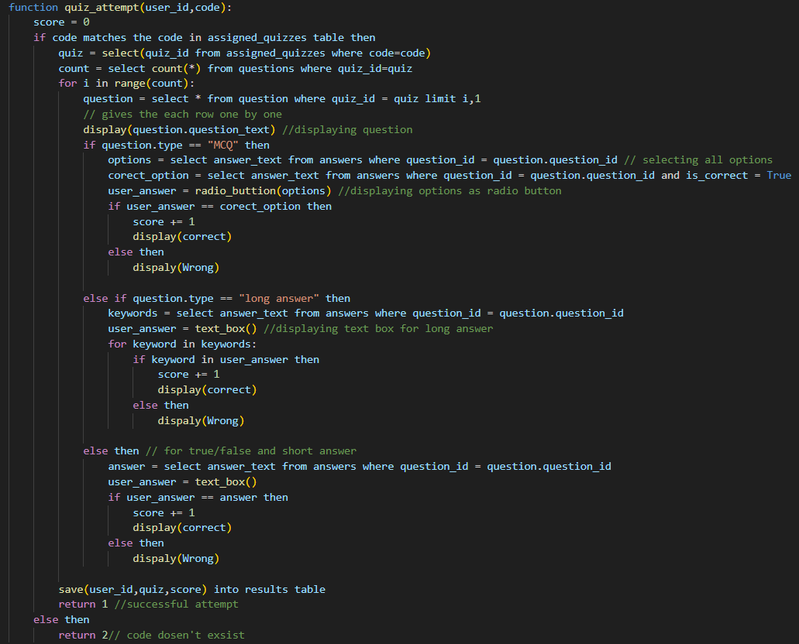

Key variables:
- user_id (integer value)- used to identify a student in the user table and used to keep a track of students result
- code (integer value)- used to access the quiz
- correct_option (string value)- stores the correct option
- user_anwer (string value)- users input to the question
- score (integer value)- keep track of the users score
- question (dictionary)- stores a row from the question table

Leaderboard update algorithm
This function will be used to update the leaderboard when a user completes a quiz. The function takes all the score of the quizzes completed by the students and calculates an average. It will access all the scores from the results table and update the leaderboard table accordingly.

Pseudocode:
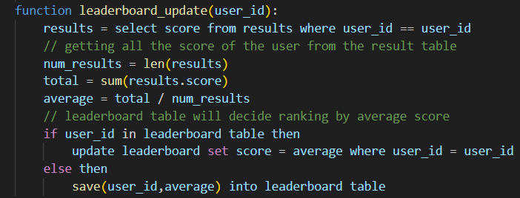
Key variables:
- user_id (integer value)- unique identifier for each user which will be used to extract results
- num_results (integer value)- stores the number of results associated with the user
- average (integer value)- will update the score in the leaderboard for the user
- total (integer value)- stores the total score of user from all the quizzes done

Key Variables
I have previously talked about the key variables for each algorithm but now I will be looking at key variables throughout the program. This will include new variables that haven’t been mentioned in the algorithms. This will help me in validation and keep track of what is being stored in the main variables. This will also showcase how variables are being reused around the program.
Name | Data Type | Purpose
login_attempt | An integer | This will keep track of the login attempts by the user and if the login attempts reach to 3 then the program will lock
theme_colour | A Hex value | Will keep track of the user them colour choice, users can use this variable to customise the homepage colours and more
max_attempts | Constant integer value | This will be a constant value storing the value 3 which will be used for validation as it will define the lockout limit
password_confirm | A string | This will be used as a temporary variable during the registration process to make sure that the passwords match
option_selected | An integer | This keeps track of what button the user presses on the homepage and which function to run
current_interface | A string | This will keep track of what interface the user is on and will be used in error diagnostics
temp_questions | An array | This will store all the questions that have been selected from the database or has to be saved
score | An integer (global) | This will track of the users score and will display it on the student’s homepage
colour_options | An array (global) | This will be used to store all the available theme colours that the students will be able to select
error | A string (global) | This will store a string saying, “Invalid Error”. As I will use this string a lot it is better to save it in a variable rather than type it out repeatedly

2.5 Validation
Validation is going to be an essential part of my program as it will be used to make sure that the program is running as expected. Any errors will be found and will make sure that the stakeholder gets a bug free and smooth program.
Since I will be using tkinter to make this program, I need to show how validation will connect to my input methods. This will show the different ways my user can interact with my program and how invalid input will be prevented.

Text Box
This is a built-in part of tkinter which means and allow any text to be inputted. The text box will be used in many modules as passwords, answers and quiz code. The text box will have different checks for different functions such as when entering a quiz code, it will ensure that it is numeric only. It will also be used to check for empty strings and will keep prompting the user until they type something. By checking the input before passing it to the algorithm which means that I can prevent various errors.

Radio Button
Radio buttons are a part of tkinter and will be used in Account type selection and MCQ questions. Radio buttons give multiple choices to the user but only lets them select one. There will be 2 options for account type selection and 4 options for MCQ answers. I must make sure that the user has selected an option before submitting the input to make sure that there is no error in the system.

Button
This is also a part of tkinter and already perfectly designed. Whenever the button is pressed, it goes to the function it is linked to. The buttons will mainly be used in the homepage and used to confirm answers. As they don't pass any variable there is no risk of error.

Scale
This is a built-in part of tkinter which allows to select a value from a given range. A sliding bar can be used by dragged by users to select a value on a given range. This ensures that the user doesn't input invalid values.

2.6 Testing Methods
Testing is an important part of the development as it makes sure that the functions are usable on when created. Further testing will make sure that it meets stakeholder requirements and has no bugs. All the data input for the testing and console output will be recorded for debugging. I will use different type of test data such as normal, boundary, extreme and erroneous to make sure that system works properly/
After development, I will conduct a final test to make sure that all the functions interact correctly with each other and ensure that it meets the stakeholder requirements.
Unit Testing
This involves testing individual functions and modules such as the login or student homepage. This will make sure that the function work properly and can safely be integrated with the rest of the program.
Integration Testing
This will be used to test the interaction between different functions such as the homepage and quiz attempt. This will make sure that the function work together without logic or data errors.
Validation Testing
This method ensures that the inputs are correctly handled. This is important as it makes sure prevents error in the system and invalid entry in the databases. Doing validation testing also make sure that data can't be accessed from my databases using SQL injection.
User Acceptance Testing
Allowing the stakeholders to test interact and interact with the system. This allows for more improvements and confirms that the program meets the stakeholder requirements.
System Testing
This will be the test of the whole system in a real environment and makes sure that it meets the success criteria, is bug free and gives user satisfaction. If the program passes this test, then it means it is table, meets the requirements and is ready to be released.

Testing Checklist
The table below shows how testing will be conducted during the development and how it will be displayed. Each test links to the success criteria and ensure that the program is working as intended.
Test No. | Feature being tested | Expected Output | Passed?
1 | Logging in with correct password | Redirect to teacher homepage
2 | Logging in with wrong password | Displays “wrong password”
3 | Registration | Account is created and redirected to homepage
4 | Quiz Creation with valid input | Quiz is saved and redirected to teacher homepage
5 | Attempting quiz with invalid code | Display “wrong code”
6 | Pressing “confirm” when attempting quiz | Mark the question and update user’s total marks
7 | Submitting long answers | 1 mark for each keyword
8 | Clicking “past results” | Showing all past attempts and the marks
9 | Colour changer | Background changes colour according to user’s choice
10 | SQL injection using text boxes | Doesn't let it pass through and asks for input again
11 | Brute force login | Doesn't let user login after 3 attempts
12 | Clicking “Leaderboard” button | Displays leaderboard

Development
In this section, I will be implementing the solution in the section by following the design I have created. I will be using an iterative and modular approach in which I will code, test and improve the module I am building before moving to the next one. Before, developing the different modules, I must create a database which will be responsible for storing all data and making essential feature work such as quiz page or reports.

3.1 Database Development
The database is the backbone of the system as without it the system cannot work. It stores all data such as quiz questions, user data and leaderboard rankings. I chose to use SQLite as it is perfect to use with small to medium sized applications and doesn't require a separate server. It also stores data in on .db file which ensures integrity of data and makes it easier to manage. SQLite is a good choice as it can be used easily with python’s built in sqlite3 module which will allow me to create, modify and query data easily.
For creating and managing the different SQLite tables of my database, I will be using DB browser which provides a visual interface which allows me to create tables, define data types and establish relationships. This allows allow me to easily access all the data stored in the different tables and allow me to verify my test results.
I have also made sure to make all the tables are in 3NF. This ensures that all fields depend on the primary key and there is no transitive dependency. This makes sure that the database is efficient, avoids duplication, and supports fast queries. By normalising the tables to 3NF, I have ensured that quiz questions, answers, users, results, and assignments are stored cleanly and can be linked using foreign keys.

Users Table
This table will be responsible for storing the username, age, password, name and role of the user. A record will store all this information about one user, and it will be unique to one user. The primary key user_id will allow the different records to be differentiated, and I have made the username field be unique as it will prevent confusion.

Table structure:
Table code:
Justification:
User_id is the primary key and is auto incremented which means the integer number is created and handled by the table itself. The user_ id also acts as foreign key as it links users table to the results and leaderboard table which ensure that each result belong to an actual user. This is very useful as it prevents orphan records. All the rest of the fields require a value as without a value some features of the program won't work. The age field is an integer as it will allow for constraint checks without worrying it about being a string. The role checks for “teacher” or “student” is to prevent different roles being inputted which may cause trouble in the program.
Table Relationship:
- One user can create many quizzes (One to many)
- One user can appear once in the leaderboard (One to One)
- One user can have multiple results (One to many)
- One user can create multiple assignments (One to many)

Quiz Table
This table will store the title and the user_id of the person who created it. A record will store the quiz_id, title and user_id of a quiz. The primary key is quiz_id which will be used to differentiate each quiz.
Table Structure:
Table Code:
Justification:
Quiz_id is the primary key of this table and is auto incremented which means no repeats happen. The quiz_id is also foreign key in the question table and makes sure that questions are linked to the correct quiz. The user_id is a foreign key which links the user table and quiz table, this allows for the system to check the person who created this exists and prevent orphan records. A special user account with user_id “0” is supposed to represent system which means that the quiz is built into the system.
Table Relationship:
- One quiz contains many questions (one to many)
- One quiz can be in multiple results (one to many)
- Each quiz is created by one User (many to one)
- One quiz can be in multiple assignments (one to many)

Question Table
This table will contain the question text, type and quiz id. Each record will contain a detail of a single question from a quiz. It contains a primary key and foreign key.
Table Structure:
Table Code:
Justification:
The question_id is the primary key of the table and is auto incremented to make sure each question has a unique identifier. The question_type field is a text column and restricted to 4 predefined values, this is to prevent wrong values being inputted and causing errors. The quiz_id is a foreign key which links the question table to quiz table, this is to identify which question belong to a quiz and make sure that correct question is being selected. All the fields except question_id are required, to ensure data integrity and completeness of the table.
Table Relationship:
- Many questions can be in one quiz (many to one)
- One question can have multiple answers (one to many)

Answer Table:
This table contains the question id, answer text and if it is correct. Each record is an answer or option for a question. It contains a primary key and a foreign key. There can multiple records linked to the same question as it can be keywords for a long question or multiple choices for MCQs.
Table Structure:
Table Code:
Table Justification:
The answer_id is the primary key of the answer table and autoincrements which makes sure that each answer has a unique identifier. The question_id is the foreign key in the table which links the answer table to question table. This makes sure that each answer is associated with a valid question and therefore prevents orphan records. The answer_text stores text which will be displayed to the user. The is_correct column stores a single integer value which indicates if the answer is correct for the linked question. This is useful for MCQs where one answer is correct, and the other are incorrect. The is_correct column being defaults to 1 is as the rest of the question type also require correct answers. All columns are required to maintain consistency and preserve data integrity.
Table Relationship:
- Many answers can be in one question (Many to one)

Assignment Table
It is responsible for storing the quiz id, user id, code, date issued and expiry date. Each records stores information for a single assignment. This table allows teachers to assign quizzes by sharing the code with their students. It contains a primary key and two foreign keys.

Table Structure:
Table Code:
Table Justification:
The assignment_id is the primary key of the table and auto increments ensuring each record has a unique identifier. The user_id column is the foreign key which links the user and assignment table ensuring that the assignment is done by a valid user. Quiz_id column is another foreign key which links the quiz and assignment table ensuring that the assignment contains a valid quiz. The assigned_on and expires_on column is used to the creation and expiry dates which allows to check if the assignment can still be completed. All columns are required as it ensures data integrity. The code column requires a unique value so it can prevent two quizzes being selected.
Table Relationship:
- Many assignments can belong to one user (many to one)
- Many assignments can have one quiz (many to one)

Results Table
The results table contains the quiz id, user id, result and the date it was completed. One record contains a result of a user and there can be multiple records linked to one user. It contains a primary key and two foreign keys. This table will allow users to access their past result and see improvements.
Table Structure:
Table code:
Table Justification:
The result_id is the primary key which is also auto incremented which ensures that each result has a unique record. The quiz_id is a foreign key which links the results table to the users table and ensures that each result belongs to a valid quiz. The user_id is another foreign key which links the result to users table and ensuring that each result is associated to an existing user. The date_completed column stores that date on which the quiz was taken to allow users to track their progress and improvement over time.
Table Relationship:
- Many results can belong to one user (Many to one)
- Many results can have the same quiz (Many to one)

Leaderboard table
The leaderboard table is responsible for storing user id and score. One record contains one user's total score. The leaderboard is used to keep track of a user's score and is constantly updated to make sure it is correct. It contains a primary key and a foreign key.
Table Structure:
Table Code:
Table Justification:
The leaderboard_id is the primary key, and it auto increments which ensure that each record has a unique identifier. The user_id is the foreign key and links the leaderboard table to the user table, this ensures that a record belongs to valid user. This foreign key allows the system to access the username so it can be displayed beside their score and rank. The score is an integer field which stores the total score accumulated from all quizzes attempted by the user.
Table Relationship:
- One leaderboard entry belongs to one user (one to one)

ERD Diagram
This is the updated ERD diagram as my previous diagram in the design section is not in 3NF. Now the diagram correctly represents the relationship, and all the fields depend on one key.

Connection to program
Now that I have created all my tables in a file called “quiz.db”, I can import them into python using sqlite3 library. To keep my project organized, I put all my code related to database selection, insertion, updating and searching into a separate file called “user_functions.py”. The main program will be able to use the reusable functions instead of repeating SQL code.
Function in user_functions.py will handle tasks:
- Insert new user details
- Checking login details
- Inserting quiz results
- Retrieving questions and answers of a quiz
- Updating the leaderboard
The following code will be used in “users_functions.py” to access the database:
import sqlite3
connection = sqlite3.connect("quiz.db")
cursor = connection.cursor()
This connection can be reused by all functions in the file. A centralised connection will make the program efficient and avoid repeated lines of code. I can just use connection.commit() in each function to make changes in the database. In the end, the database connection will be closed using connection.close().
This is a flow chart representing how the database and program will be connected.

Database Validation
The database is responsible for storing all information related to the program, so it is vital to make sure that the data inside the database is valid. Below is the main type of validation used in user_functions.py to ensure correct data is inserted.
1. Not Null Constraints
Used on all fields except the auto incremented fields and prevents incomplete row being inserted. It checks in fields such as username, quiz title and password, ensuring that the values are provided.
2. Unique Value Constraints
Used in fields username and code. This is to ensure that there are no duplicates in the field and thus prevents errors. This prevents two users having the same username and prevent login conflicts.
3. Check Constraints
Used in the role and question type field. This makes sure that the values specified are only inserted. This is useful for stopping users inserting incorrect values with intention to break the system.
4. Primary Keys
Primary keys are used to identify each record in the table. This ensure that records are identified so it can be updated, deleted or accessed safely.
5. Foreign Keys
They are used to establish relationships between tables. It prevents orphan records and preserves referential integrity.
6. Data Types
Ensures that all text fields have text and all integer fields use integers. This is useful when selecting data such as scores and performing calculations without worrying about data types.
7. Auto Increment
Used in all ID fields which are primary keys and ensures that no IDs are duplicated. This ensures that each record receives a unique identifier automatically and removes the need of manual ID tracking.

3.2 Login Module
This is the first functional part of the system and will act as the foundation for all other modules. The login module purpose is to authenticate users by validating their username and password against the stored data in the database. The module will take user’s input from the login interface and pass it into the backend function inside user_functions.py, which uses the SQLite database to authenticate the input. The function will return a result which the login interface will use to display an appropriate message or redirects users to their respective homepage. This module ensures the security of the system and ensures that user can access feature given to their roles.

Backend code
The login functionality is handled by login( ) in users_function.py. This function has the responsibility of validating the username and password passed through. It interacts with the database directly to validate the details. The function performs several checks, returning specific values that GUI will use to decide what to do next.
Justification of code:
In line 11, the function is taking username, password and attempts as parameters.
In line 12 and 13, an if statement is used to check the attempt limit. If attempt equals 3, then the function immediately returns “Lock” which causes the login interface to disable the input fields. This prevents brute force attacks and fulfils the security requirements in my success criteria.
In line 15 and 16, an SQL query is being executed which retrieves hashed passwords for the username given. By using placeholders “?”, which ensure that user input cannot alter query structure, I am preventing SQL injection attacks. If the result is None then it means the username doesn't exist and the function immediately returns “None” to the login interface which displays an appropriate message.
In line 19 to 25, the bycrypt.checkpw() is used to securely compare the entered password with the hashed password stores in the database. If the password matches, a second SQL query is executed to retrieve the user’s role and name. The fetched data is returned to the interface so it can redirect to the correct homepage and update the welcome page.
If the password is incorrect, the function immediately returns “False”. The login interface then displays an appropriate message to the user and increments the attempt counter by 1. This meets the validation requirements as it denies accessing invalid users to the system.

Frontend code
Justification of initialise method code:
The LoginPage class inherits from Frame, which allows it to be an individual screen inside the main window. The constructor uses the super().__init__() makes sure that the parent class is properly initialized before the login class elements are added. The variable self.attempts is initialized to 0 and is used to track how many times a user has entered the wrong password. This meets security requirements as it allows the system to track attempts and lock program after 3 attempts.
Self.App stores the reference to the main App class. This allows LoginPage to access interface functions such as label(), button(), entry() and colour selector. This makes sure that the interface is consistent across all the pages and satisfies success criteria by providing a simple and consistent interface.
Lines 134 to 139, creates labels and entries on the page using reusable methods from the App. The label guides users to enter their username and password whereas the entry widgets store the users input to authenticate. Using the functions from the App class allows consistent font, style and colour theme across the entire program which fulfils one of my success criteria.
Lines 141 to 151, displays a line at the bottom left of the page which allows new users to register. A separate Button() is created manually instead of using the method from App as the text needs to be underlined which is not offered by the App button. The register button executes App.show_frame(“Register Page”), which redirects use to the registration screen. This improves usability and show a clear and simple navigation system.
Lines 153 and 154, the top right button allows the user to change the colour of the page. This feature was specifically requested by the stakeholders during feedback and makes the interface feel customisable. The login button calls login_check() method, which handles validation and communicates with backend code. This separates the interface from the backend and keeps the interface responsive.
Justification of login_check method:
This method is responsible for handling the interaction between the backend code and the login interface. It validates user input, calls the function login from user_functions.py which return a value which is interpreted and used to update the GUI. This method makes sure that the login process is secure, fast and user friendly which fulfils my success criteria for validation.
When the valid input is confirmed, the method calls the login() function and passes three parameters which are user input and the attempt limit. The returned values determine how the interface should act. This modular design allows the interface to remain simple.
If the function returns “None”, then it means that the username does not exist in the database. This interface displays an error message to the user which provides clear feedback.
If the function returns “False”, then it means the password provided doesn't match the stored hashed password. An error message is displayed to the user. The attempt counter is increments and the attempt label is updated. This meets security requirements as it is tracking failed attempts.
If the function returns a list, then it means that the user has logged in successfully. The list contains the users name and their role. The name is used to update the welcome message. The role is used to direct the user to the correct homepage.

Login Testing
Test No. | Test Description | Input | Expected Outcome | Actual Output | Pass/Fail
1 | Username field is left blank | Username = “”  Password = “ibr@him14” | GUI output “Error: Enter all details” | Username not found | Fail
2 | Username field is left blank | Username = “”  Password = “ibr@him14” | GUI output “Error: Enter all details” | Same as expected | Pass
3 | Password field is left blank | Username = “miz”  Password = “” | GUI output “Error: Enter all details” | Same as expected | Pass
4 | Both fields are blank | Username = “”  Password = “” | GUI output “Error: Enter all details” | Same as expected | Pass
5 | Username does not exist | Username = “wrong”  Password = “ibr@im14” | GUI output “Error: Username doesn't exist”  Backend return value: None | Same as expected | Pass
6 | Wrong password | Username = “miz”  Password = “wrong” | GUI output “Error: Wrong Password”  Backend return value: False | Same as expected | Pass
7 | Wrong password 3 times | Username = “miz”  Password = “wrong”  Input this 3 time | Backend return value: Lock  Login input field is disabled | Same as expected | Pass
8 | Correct student password and username | Username = “miz”  Password = “ibr@him14” | Backend return value:  [“student”, “ibrahim”]  Redirects to student homepage | Same as expected | Pass
9 | Correct teacher password and username | Username = “teacher”  Password = “teacher1” | Backend return value:  [“teacher”, “ibrahim”]  Redirects to teacher homepage | Same as expected | Pass
10 | Wrong password 2 times and correct once | Username = “miz”  Password = “wrong” x2  then  Password = “ibr@him14” | GUI output: “Error: Wrong password” x2  then  Backend return value:  [“student”, “ibrahim”]  Redirects to student homepage | Same as expected | Pass
11 | SQL injection | Username = “ OR 1=1”  Password = “ibr@him14” | GUI output “Error: Username doesn't exist”  Backend return value: None | Logged in | Fail
12 | SQL injection | Username = “ OR 1=1”  Password = “ibr@him14” | GUI output “Error: Username doesn't exist”  Backend return value: None | Same as expected | Pass
13 | Username and password with trailing spaces | Username = “miz ”  Password = “ibr@him14 ” | Backend return value:  [“student”, “ibrahim14”]  Redirects to student homepage | Same as expected | Pass
14 | Password case sensitivity | Username = “miz”  Password = “IbR@him14” | GUI output: “Error: Wrong password”  Backend return value:  False | Same as expected | Pass
15 | Colour selector doesn't break login page | Click colour selector button and select colour | Theme colour changes | Same as expected | Pass
16 | Colour selector doesn't break login page | Click colour selector button and select no colour | Theme colour doesn't change | Colour changes | Fail
17 | Colour selector doesn't break login page | Click colour selector button and select no colour | Theme colour doesn't change | Same as expected | Pass
18 | Wrong password 1 time and then correct password | Username = “miz”  Password = “wrong”  then  Password = “ibr@him14” | GUI output: “Error: Wrong password”  then  Backend return value:  [“student”, “ibrahim”]  Redirects to student homepage | Same as expected | Pass

Error Fixing
Test no.1:
The purpose of the test was to confirm the GUI rejects no input data. However, the GUI doesn't reject and sends it to the backend, which is not able to find a blank username, so a username not found is given back. This issue was fixed by adding a presence check in the login_check method. An if statement is added at the start of the method to check if the user input is blank and then sends an appropriate response.
Test no. 11:

Evidence of testing
This screenshot shows evidence for test no.1 and shows that an error message is displayed when the username field is left blank. This shows that the validation is working correctly.

This screenshot shows evidence for test no.2 and shows that an error message is displayed when the password field is left blank. This shows that the validation is working correctly for the password field.

This screenshot shows evidence for test no.3 and shows that an error message is displayed when both input fields are left blank. This shows that the validation is working correctly for both fields simultaneously.

This screenshot shows evidence for test no.4 and shows that an error message is displayed when the username doesn't exist in the database. This shows that the username validation is working correctly.
This screenshot shows evidence for test no.5. It shows that an error message is displayed when the password is incorrect and updates the password attempt counter. This confirms that the password validation is working perfectly.

This screenshot is evidence for test no.6 and shows that is prevent brute force by locking the input field after 3 wrong attempts. This confirms that the password validation is working perfectly.

This screenshot shows the success of test no.7 as a student account with correct details was redirected to the student homepage. This shows that all the validation are working properly to ensure the student logs in.

This screenshot shows the success of test no.8 as a teacher account with the correct details was redirected to the teacher homepage. This shows that all the validation are working properly to ensure that a teacher can log in.

This screenshot shows evidence of test no.10 in which SQL injection happens through the username fields. It shows that injection is prevented by the placeholder used in the SQL statement tin the backend code. This confirms that the validation in the backend code is working properly.

This screenshot shows test no.13 and we can see that the colour selector is working perfectly and doesn't break the login page.

The login module was tested using normal, boundary and invalid cases. All the tests gave the expected results which shows that that the modules are working perfectly and meet the success criteria. Tests which were not given screenshot evidence will have video evidence.

3.3 Registration Module
This module allows new users to create an account and access the system. It collects their details such as name, age, role, username and password. These details are then stored securely in the database. This module is significant as it verifies new data being stored and allows controlled access to the users.

Backend Code
The register function exists in user_functions.py and is responsible for storing new users' details. The function takes in 5 parameters which have already been validated by the frontend code. This function is responsible for handling the database operations for user creation and leaderboard entries. The function returns a value to indicate if the entry was successful.
Justification of backend code:
In line 27, the function takes in five parameters: name, age, username, password and role. These parameters represent the required data for making a valid user record. The frontend code has already validated the values, so they are ready for insertion.
In line 28 and 29, the plaintext password provided to the user is hashed and stored into a separate variable. Hashing converts the password into a fixed encrypted value which cannot be reversed. This prevents attacker from accessing the user’s original password if the database is compromised. This improves account security and prevent unauthorised access of user accounts.
In line 30 to 33, a SQL insert query is executed to store user’ name, hashed password, age, role and username into the user table. The query uses placeholder values “?” which ensures that input cannot alter the query structure. This prevents SQL injection and meets the system’s success criteria. If there is an error produced such as integrity, then it means that the username already exists in the database. False is returned if this happens and an appropriate message is displayed by the GUI. This maintains the database integrity and allows unique usernames.
In line 33 to 37, the function checks that the user’s role is set to student and then two SQL queries are executed. The first query retrieves the user id of the new user record. The second query uses this user_id as a foreign key to create a record in the leaderboard table. The leaderboard record will be used to update student’s quiz score in the future.

Frontend Code
Justification of initialise code:
The RegisterPage class inherits from Frame, which allows it to be an individual screen in the main window. The super.__init__() constructor is used to make sure the parent class is initialized before the register page widgets are created. The variable self.App store a reference to App class, which allows the register page to use App’s methods. By using interface functions from App class allows a consistent interface on all the pages and satisfies the success criteria of the interface being simple and consistent.
Line 188 to 208 is creating the register page interface by using labels, entries and radio buttons. Line 204 creates a button which calls register_check() method which within the register class. This function is responsible for validating the user’s input and passing it to the backend code.
Justification of register_check method:
This method is responsible for validating user input and handling the interaction with the backend logic code. It acts as control layer between the GUI and the backend code. It provides immediate feedback to the user and only allows valid to be passed to the backend. This method ensure that the registration process is secure, fast and reliable which satisfies the success criteria.
Line 212 to 215 contains if and elif statement to validate user input. Line 212 checks if any of the input fields are empty and gives an appropriate response to the GUI if a field is missing. I have used strip() with each field to ensure whitespaces are removed before validating the input. Line 214 checks if the password length is smaller than 8 characters. This improves security as the passwords will be more secure and this fulfils the security related success criteria.
If all validation is passed, Line 219 calls the register function and passes the validated input required. If the register function returns True, which confirms that a user has successfully been added to the database. The user's key details are stored in App class variables, so other pages can reuse which provides a consistent experience. The user’s role is determined by their entry field and redirected to the correct home page. If the register returns false, then it means that the username already exists in the database and an output is given to inform the user.

Test Tables
Test No. | Test Description | Input | Expected Outcome | Actual Output | Pass/Fail
1 | Name field is left blank | All inputs filled except name field | GUI output “Error: Insufficient Information” | Same as expected | Pass
2 | Age field is left blank | All inputs filled except age field | GUI output “Error: Insufficient Information” | Same as expected | Pass
3 | Password field is left blank | All inputs filled except password field | GUI output “Error: Insufficient Information” | Same as expected | Pass
4 | Username field is left blank | All inputs filled except username field | GUI output “Error: Insufficient Information” | Same as expected | Pass
5 | No role option is selected | All inputs filled except selecting a role | GUI output “Error: Insufficient Information” | Same as expected | Pass
6 | Password has below 8 characters | Password: 8  All other inputs are filled as well | GUI output: “Error: Password too short” | Same as expected | Pass
7 | All fields are left blank | No input | GUI output: “Error: Insufficient Information” | Same as expected | Pass
8 | Register as a teacher | All inputs filled with teacher selected as account type | Backend return value: True  Redirects to teacher homepage | Same as expected | Pass
9 | Register as a student | All inputs filled with student selected as account type | Backend return value: True  Redirects to student homepage | Same as expected | Pass
10 | Colour selector doesn't break register page | Click colour selector button and select colour | Theme colour changes | Same as expected | Pass
11 | Database has unique usernames | All inputs filled with username being a username which already exists | Backend return value: False  GUI output: “Error: Username already in use” | Same as expected | Pass

Evidence of testing
This screenshot shows evidence of test no.1 which shows displays an error to the user as the name field is empty. This shows that the presence check for the name field is working.
This screenshot is test no.2 being executed and proves that the presence check is working perfectly. This confirms that age field validation is working perfectly.
This screenshot is evidence of test no.3 and shows that password validation is working properly. The user is informed if the field is left incomplete. This ensures that the backend code has all the information it needs.
This screenshot is evidence for test no.4 which ensures that the username field is not left empty. The user is informed by displaying a message on the GUI.
This screenshot is evidence for test no.5 which checks if an account type has been selected. An if statement is used to check if the radio button holds a –1 value which means that no value is selected. This is very important as the account type will be used to redirect the user to the correct homepage.
Screenshot evidence of test no.6 which tests if the system allows a password below 8 characters. A checker is used to ensure that a proper password is used to protect the account and can't be guessed easily. The user is informed if the password is too short.
This is screenshot evidence for test no.7 which tests the response of the system if all fields are left blank. We can see that the correct response is given which mean presence check validation is working perfectly fine.
This is screenshot evidence for test no.8 which is testing if the redirection system is working correctly according to account type. In this test we register as a teacher, and we are redirected successfully to the teacher homepage.
This is screenshot evidence of test no.9 which is testing the redirection system if registering as a student. We can see from the screenshot that the student test account is redirected correctly to the student homepage

This is screenshot evidence for test no.9 which test if the colour change is working correctly on the register page. We can see from the register page that the colour is successfully changed which mean it is working correctly.
This is screenshot evidence for test no.10 which shows the uniqueness of username being checked. If a username already exists then the details are not saved and the user is informed to enter another username. This keeps the integrity of the database.

The registration module successfully validates user input and prevents invalid or duplicate data to be stored in the database. The registration module has passed test cases with invalid, boundary and valid data. The interface is also in sync with the rest of the program. This shows that the registration module meets the success criteria of being secure and having no bugs.

3.3 App module
This module is vital to the system as it is responsible for defining the different pages of the system and managing which page is displayed to the user. It is also used to store information about the user which will is required by most classes. It also stores methods of creating labels, buttons and radio buttons which is to promote reusability as it requires only width and coordinates to create the widgets.
Justification of initialise method:
The methods start of by setting the colour which will be used across all pages, which is grey. The super.__init__() constructor is used to make sure the parent class is initialized before the frames and widgets are created. Line 14 to 18 defines empty variables which will store important information about the user. These variables are assigned when login or registration process happens. They are stored in the App class so all other classes can access its attributes when needed.
Line 20 to 24 is configuring the window layout of each page. We can see that the whole window is being configured into one row and column which allows easier management of widgets and helps to keep the pages organised.
Line 26 to 38 is used to define each page of the system and store them into a dictionary. This allows for pages to be easily manageable and be raised when needed. The starting page is displayed by the command on line 38 which ensures that the first page that is displayed when starting the application is the starting page.
Justification of show_frame method:
This method is called by other classes to switch pages. The method takes in a parameter which stores the page to be raised. The page_name is stored in the variable self.current_page which allows it to be accessed by other classes when needed. The class is accessed from the dictionary using its name. The page is raised to the front, and the instance of the class is returned.
Justification of label method:
This method is responsible for creating labels. It takes in parameters about its parent class the label will be created in, the text content, label size and its coordinated. This method is used to improve reusability and repetition of properties such as background and foreground colours. The label is placed using the coordinates and returned so the label so it can be modified if required.

Justification of entry method:
This method is responsible for creating entries. It takes in parameters about its parent class, the entry size, the coordinates and the width. This also improves reusability as entries will be used in many classes. Line 53 and 54, set the width of entry if a parameter is given. The entry field is placed is using the coordinates and returned so the input of the entry can be fetched and processed when required.
Justification of button method:
This method creates buttons withing the system. It accepts parameters containing its parent class, button text, button size, coordinates and the command it will execute. Using a method to create buttons allows reusability and prevents unnecessary repetition of details. Line 66 and 67 sets the width of the button if given otherwise it uses the default width. The button is placed using the specified coordinates. The button is not returned as it doesn't need to be accessed or modified after creation.
Justification of set_colour method:
This method allows user to select a new colour using a colour picker, which is applied to the background of all window pages. Using a method means I can use it a button command. Line 73 to 86 iterates through every page and its widgets and accordingly change its colour. Each widget has different properties to be changed such as the radio button requires to update it select colour and background colour, whereas the entry widget only needs the foreground colour changed.
Justification of radio_button method:
This method is responsible for creating radio buttons which allows user to only select on option. It takes parameters which contains the parent class, list containing text for each button, coordinates, size and width. The default selected value is set to –1, this is to recognise if no option has been selected. A for loop is then used to create a radio button for each item in the list. Each radio button is placed using the coordinates, however the y coordinate is incremented so they all appear stacked vertically. The placeholder value is returned to signify which option has been selected by the user.
Justification of App class:
Making a parent class follows the rule of modular programming. By having common widgets and shared variables makes the program easy to maintain and debug. Any change to design of the program can be implemented through this class instead of modifying ever page manually.
Testing of App class:
The class was tested by switching through all the pages and checking if the shared data such as username and name is same across all pages. Colour changes were also tested and ensured that it is applied to every GUI element. The widget methods were also working successfully in other classes and demonstrated the reusability it provides.

//comments
Login improvements:
Added .strip() to prevent trail spacing

Iteration cycle
- Reading writing
- Testing validation- ask stakeholders
- Finished product

